Testing the Vitruvian Man  ID: 11309 | Time Required  40 minutes (collect data)  25 minutes (given data)

Activity Overview
In this activity, students will collect height and wingspan measurements from the class, and then create a scatter plot of the data. They will determine a line of best fit for the data using the Manual-Fit command. Through teacher-led discussion, students will learn the properties of a line of best fit.
Topic: Two-variable statistics
- Scatterplots
- Lines of best fit

Teacher Preparation and Notes
- This activity has students collect data as a class and then use the data to construct a scatter plot and line of best fit. To collect data, students will need a tape measure or meter/yard stick for each group of students.
- If students do not have time to collect data, the teacher can give the class a data set for 2007 NBA recruits to be used for the scatter plot and analysis. To set up these lists on the calculator, press  and select SetUpEditor. Press   and select HEIGH and then WINGS.
- Before beginning the activity, have students turn off all functions from the Y= screen and turn off all stat plots.
- This activity can be used as a teacher-led discussion about line of best fit or as a review/assessment of a line of best fit lesson.
- To download the student worksheet and list files, go to education.ti.com/exchange and enter “11309” in the quick search box.

Associated Materials
- StatWeek07_Vitruvian_worksheet_TI84.doc
- Lists: HEIGH.8xl, WINGS.8xl

Suggested Related Activities
To download any activity listed, go to education.ti.com/exchange and enter the number in the quick search box.
- Predicting White Blood Counts (TI-84 Plus family) ⎯ 5784
- TI: Line Up #2 (TI-89 Titanium) ⎯ 3418
- Run me a Linear Regression (TI-84 Plus family) ⎯ 5137
- daVinci's Proportions (TI-84 Plus family) ⎯ 5546
- Round about Circles (TI-Nspire technology) ⎯ 8554
- Find Line of Best Fit (TI-Nspire technology) — 9883

Step 1 – Collecting the data
Divide the class in small groups. Have each student measure his/her height and wingspan. The wingspan is measured from the longest fingertip of one hand to the longest fingertip of the other hand, with the arms held perpendicular to the body. Choose to use either centimeters or inches. |  |  |  | 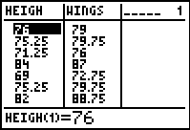
The data should be recorded in LHEIGH and LWINGS, or L1 and L2. To enter the title for a list, press  , go to the top of L1 and arrow to the right until ➢ appears. Type the title and press .
There are several options for distributing the data to students.
a) If using TI-Navigator, have students enter the data on a class computer and then distribute to each student.
b) Without TI-Navigator, the information can still be input on a class computer and then the file sent to each student with the TI ConnectTM software.
c) Choose one student’s calculator to be the “collector”. Send the lists calculator to calculator.
Problem 2 – Creating a scatter plot
Some may argue that height is the independent variable because wingspan is thought to be determined by height. However, others may argue that neither are independent or dependent variables because height and wingspan are determined by genetics.  In Extension 2, students are asked to interchange the variables and repeat the process of calculating the line of best fit.  To analyze the data, students should determine if a pattern appears after graphing. If so, they should describe the pattern with the following terms.  - positive vs. negative association  - strength of relationship  - linear vs. non-linear |  |  |  | 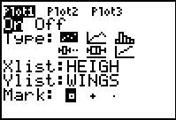  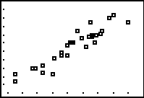
The graph should have a positive association; meaning as one variable increases the other variable also increases. The graph has a relatively strong relationship because the points are clustered close together. The graph is linear and can be represented by a straight line.
Discuss with students what the line would look like that would describe the pattern of the data. (It would have a positive slope.)

Step 3 – Drawing a line of best fit
The goal of this activity is for students to understand the concept of the line of best fit.
Discuss the properties of a line of best fit. Have students propose what they believe the line should do. At the end of the discussion the list should include:
- Positive association > positive slope
- Negative association > negative slope
- Equal number of data points above and below line.
- As many points as possible should be on the line, but the previous guidelines are more important.
- The points above the line should not be concentrated at one end, nor should the points below the line.
When students place the second point of the line on the scatter plot, the equation will appear in the top-left corner. They can modify the slope and the  y-intercept by using the arrow keys to highlight one or the other and then use the number keys to enter a new number.  After students have drawn lines of best fit on their calculator screens, have one or more students draw their line of best fit on the front board based on the scatter plot that is projected or drawn there. Use colored chalk or white board markers to distinguish the lines.  Choose one line and identify two points on it. Have the students find the equation of the line and use that equation to |  |  |  | 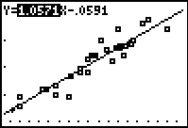  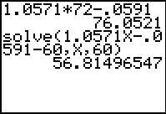
a) predict the wingspan of someone who is six feet tall and
b) predict the height of someone who has a five foot long wingspan.
The solve command, found in the Catalog ( ), has the following parameters:
solve(equation that is equal to 0, variable, guess)
Discuss with students what the equation of the line means. Since the slope of the line is very close to 1, it means that the height and wingspan are nearly equal to each other. The data and line suggest that there is a high, positive correlation between height and wingspan.
An alternative to using Manual-Fit to draw the line of best fit, students can use the Transformation Graphing App. They need to enter AX + B next to Y1 and then set A=1, B=1 and step=0.1. |  |  |  | 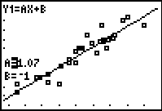
Extension 1 – Calculator-generated lines of best fit
This activity can be extended (or continued the next day) to find calculator generated lines of best fit including the linear regression line and the median-median line.  Each line can be considered a best fit model, even though their equations are different. Discuss with students how each line is determined and how the lines compare to the students’ lines of best fit.  The screenshot at the right displays the graphs of the data and the two lines of best fit. |  |  |  | 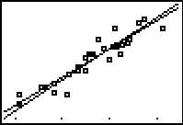
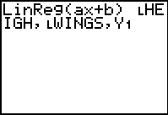 | 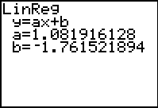 | 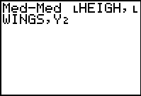 |  |  | 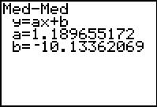
Extension 2 – Change of variables
Switch the order of the variables. For example, make the Xlist: WINGS and the Ylist: HEIGH. Calculate the lines of best fit. What is the relationship between these new lines and the original ones?
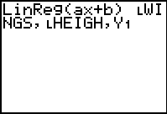 |  |  | 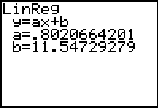
Extension 3 – Vitruvian Man
Locate a copy of Leonardo da Vinci's drawing: Vitruvian Man. He based this work on that of the ancient Roman architect: Vitruvius. Have a student measure the height and wingspan of the man in the drawing and compare the proportions to those found in this activity.

