Problem 1 – Creating a Scatter Plot
Open the list editor by pressing … Í. Enter the x-values into list L1 and the y-values into list L2.
x | 2 | 8 | 8 | 12 | 8 | 8 | 2 | 2
y | 3 | 3 | 1 | 5 | 9 | 7 | 7 | 3

Create a connected scatter plot of L1 vs. L2.  Press y , and select Plot1. Change the settings to match those shown at the right. |  | 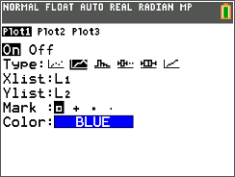
Press p and adjust the window settings to those shown at the right.  Press s to view the scatter plot. |  | 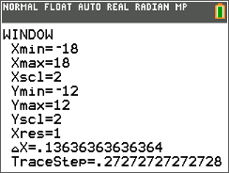
1. Sketch the scatter plot. |  | 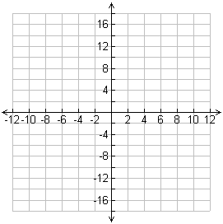
Problem 2 – Reflections and Rotations
Go back to the list editor. Enter the formula =–L1 at the top of list L₃ to create the opposite of each of the x-values in L1.  Then, enter the formula =–L2 at the top of list L4 to create the opposite of each of the y-values in L2. |  | 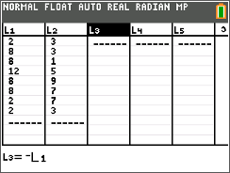
Graph the following scatter plots using Plot2, one at a time. For each combination of lists, determine what type of reflection occurred.
Press s to view Plot1 and Plot2 together.
2. x ← L3 and y ← L2  (–x, y) ________________ | 3. x ← L1 and y ← L4  (x, –y) ________________ |  | 4. x ← L2 and y ← L1  (y, x) ________________
Use Plot2 to create the following scatter plots. For each combination, determine what type of rotation occurred.
5. x ← L4 and y ← L1  (–y, x) ________________ | 6. x ← L2 and y ← L3  (–x, –y) _______________ |  | 7. x ← L3 and y ← L4  (y, –x) ________________
Problem 3 – Translations
Press … Í to go back to the list editor.  In the formula bar for L3, enter =L1–5 to translate the x-values. In the formula bar for L4, enter =L2+3 to translate the y-values. |  | 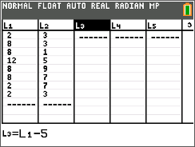
Change Plot2 so that the Xlist is L3 and the Ylist is L4. Press s to view the scatter plots.
8. Where did the image shift? How many units left/right and how many units up/down?
9. Translate the scatter plot into Quadrant 3 by editing the formula bars for L3 and L4.
L3 formula: ____________________
L4 formula: ____________________
Explain how the image shifted.
Problem 4 – Dilations
In the list editor, change the formula for L3 to =0.5*L1 and the formula for L4 to =0.5*L2.
Press s to view the scatter plots.
10. Explain what happened to the image.
11. Dilate the scatter plot into Quadrant 3 by editing the formula bars for L3 and L4.
L3 formula: ____________________
L4 formula: ____________________
Explain what happened to the image.

