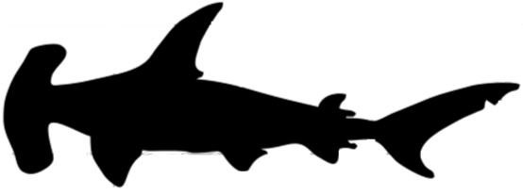  One way scientists can classify a shark is by measuring its “fork length”. In this activity we will explore why.  Total Length  Fork Length  - Explain why you think the name “fork length” is given to that particular length.  - Suppose you have caught, measured, and tagged a family of hammerhead sharks. (Do not attempt without adult supervision.) If the sizes of all the members of this family were the same shape but different sizes, determine the missing lengths. Then complete the table. Discuss any patterns you see.  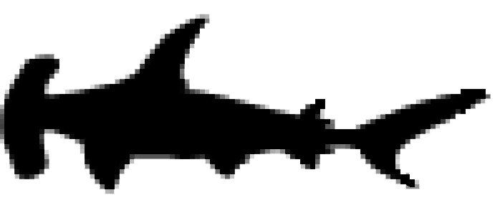  T = 100 cm  F = 80 cm  Baby Pup  T = 200 cm  F = _____ cm  Big Brother  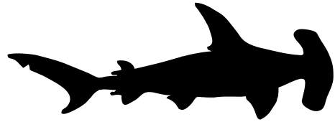  T = ________ cm  F = 320 cm  Mother
  Hammerhead Shark | Total  Length, T (cm) | Fork Length, F (cm)
  Baby Pup
  Big Brother
  Mother
- The tail, or caudal, fin has two lobes as shown in the figure.
upper caudal lobe
lower caudal lobe

Do you agree or disagree with each of these statements?
- The longer the lower caudal length, the longer the total length of the shark is.
Circle one: AGREE DISAGREE
- The longer the upper caudal length, the longer the total length of the shark is.
Circle one: AGREE DISAGREE
Explain your reasoning.

4. A baby hammerhead shark, called a pup, and its mother are tagged. Measurements are shown in the table.  A. If these points (T, F) were plotted, what is the slope of the line which passes through them?  B. What is the equation of the line which passes through these points?
  Shark | Total  Hammerhead  Length, T (cm) | Hammerhead Fork Length, F (cm)
  Baby | 90 | 72
  Mother | 400 | 320
5. A thresher shark pup and its bull father are tagged. Measurements are shown in the table.  A. If these points (T, F) were plotted, what is the slope of the line which passes through them?  B. What is the equation of the line which passes through these points?
  Shark | Total  Thresher  Length, T (cm) | Thresher Fork Length, F (cm)
  Baby | 300 | 174
  Father | 450 | 261
6. Two great white sharks are tagged.  Measurements are shown in the table.  A. If these points (T, F) were plotted, what is the slope of the line which passes through them?  B. What is the equation of the line which passes through these points?
  Shark | Total  Great White  Length, T (cm) | Great White  Fork Length, F (cm)
  Little | 500 | 460
  Big | 600 | 552
7. Enter all three of your equations in your calculator to display this family of linear functions.
Use the window 0 < x < 500 and 0 < y < 500 where Xscl and Yscl are each 50.
Then press ZOOM 5:Square to produce a “square window” with a true geometric perspective.
Below are silhouettes of three families of sharks showing how their lengths compare to the size of a human and the length of a car. Which shark matches which graph? Circle one letter choice for each shark family and write the equation of the linear model.
Hammerhead Shark A B C Equation: ______________
Great White Shark A B C Equation: ______________
Thresher Shark A B C Equation: ______________
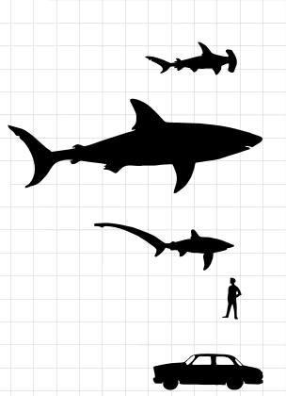
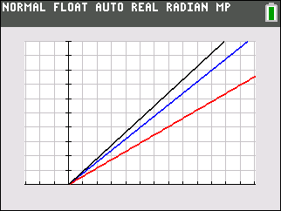
Hammerhead Shark
Great White Shark

Thresher Shark
Human
Automobile
A
B
C
Total Length, T (cm)
Fork Length, F (cm)

Graphic from http://upload.wikimedia.org/wikipedia/commons/8/8d/Sharks_silhouettes.svg.

8. Interpret the real world meaning of the slope and y-intercept of these lines.

9. Suppose you have caught several sharks which have the same total length.
Circle which one of these statements about the rear fin is true. Explain your reasoning.
A. Slopes of the lines of the three families decrease with increasing length of the upper caudal lobe.
B. Slopes of the lines of the three families increase with increasing length of the upper caudal lobe.

