Open the TI-Nspire document Solving_Systems_Using_Elimination.tns.  Extend the algebraic method of solving systems of equations by elimination to systems with three equations and three unknowns. Use the sliders to multiply each equation by a number. | 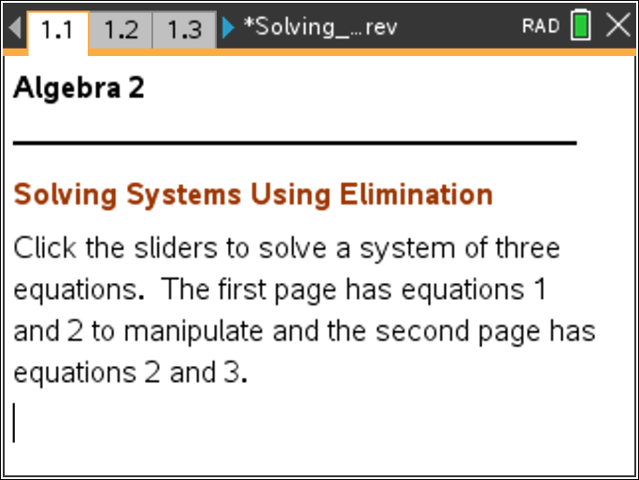

Move to page 1.2. | Press / ¢ and / ¡ to navigate through the lesson.
Solve:
Move to page 1.3.
This page has equations 1 and 2. Click the sliders to change the numbers to multiply by each equation so that, when added, the sum of the equations will result in an equation that eliminates one of the variables. You will also be told if you have chosen correctly. Work in groups of three. Each person in your group should choose a different variable to eliminate first.
1. Explain the strategy when choosing the factors needed to multiply each equation.

2. Explain the equation that results (below the line).

Move to page 1.4.

This page has equations 2 and 3. Click the sliders to multiply numbers by each equation so that, when added, the sum of the equations will result in an equation that eliminates the same variable as on page 1.3. The resulting equations will automatically be placed on page 1.5.
3. Explain why you are eliminating the same variable as on page 1.3.

Move to page 1.5.
This page has a new system of two equations and two unknowns. Use the same process to eliminate one of the remaining two variables.

Move back to page 1.4 or 1.3.
4. Why do you need to use one of the equations below the line to find the value of another variable? Find that values.

5. Which equation should you substitute into now to completely solve the system? State the solution.

6. Does the solution of the system satisfy the three equations on page 1.2? Explain.

7. Confer with your group. Does it matter which variable you chose to eliminate first? Explain.

Move to page 2.1.

2x+2y+z=3
Solve: 3x+2y-6z=-1
5x-2y-6z=17

Move to pages 2.2–2.4.
Repeat the process of elimination to solve this system of equations.
8. Jenna came into class late. Explain to her how to solve the system using the method of elimination.

9. State the solution and show that your solution satisfies the three original equations in this system.

Move to page 3.1.

3x+2y+z=4
Solve: 5x+3y-z=-2
2x + z=1

Move to pages 3.2–3.4.
Repeat the process of elimination to solve this system of equations.
10. State the solution and show that your solution satisfies the three original equations in this system.

11. What are some of the benefits of using technology when solving a system of equations?

12. In a business, efficiency experts need to solve a system with 150 variables. How many equations need to be in the system?

