Problem 1 – Row Reduction Method
Consider the system of equations:
2x + y = 5
5x + 3y = 13
Let’s use matrices to solve this system. Use a 2 by 2 matrix for the left side and a 2 x 1 for the right side.
Press   to access the MATRIX menu. Right arrow to EDIT and select 1:[A]. Define matrix A as a 2 row by 2 column matrix by typing over the dimensions in the top line. Press . | 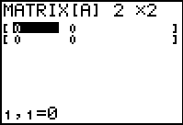
Type in the coefficients of x in the first column and y in the second column as shown. | 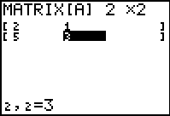
Next enter the dimensions and constants into matrix B, 2:[B], as done for matrix A. | 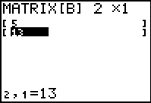
Now you need to augment matrices A and B into matrix C. From the Home screen, press  , arrow to MATH and select 7:augment(. | 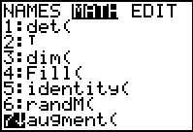
Now enter [A], [B]. To do this press       . Press  to execute the command and augment A and B. | 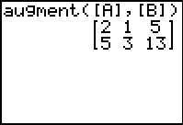
Store the result in matrix C. Press    and select 3:[C]. Press . | 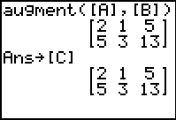
The next step to solve the system would be to eliminate x by multiplying the first equation by –2.5 and adding it to the second equation. This can be done using row operations.  Access the MATRIX menu, arrow to MATH and select F:*row+(.  (This command multiplies a row and adds it to another row.) | 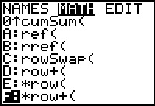
Enter -2.5, [C], 1, 2). This tells the calculator to “multiply by –2.5 matrix C’s first row, and add the result in the second row.”  Press . This will NOT replace matrix C. Store the result in matrix D as you did for matrix C.  - What is your result? | 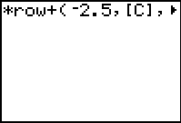
The goal is to get the coefficient of y to be 1. To do this requires doubling the second row.  In the MATRIX > MATH menu, select E:*row(.  (This command multiplies a row.) | 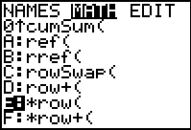
Enter 2, [D], 2). This tells the calculator to “multiply by 2 matrix D’s second row.”  Press e. Store the result in matrix D (replace it).  - What is your result? | 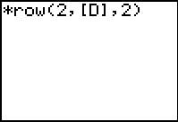
The next step to solve the system would be to eliminate y by multiplying the second equation by –1 and adding it to the first equation.  In the MATRIX > MATH menu, select F:*row+(.  Enter -1, [D], 2, 1). This means: “multiply by –1 matrix D’s second row and add it to the first row.”  Store the result in matrix D.  - What is your result? | 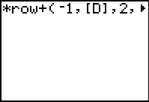
The goal here is to get the coefficient of x to be 1. To do this requires halving the first row.  Enter the command *row(0.5, [D], 1). This means: “multiply by 0.5 matrix D’s first row.”  - What is your result?  The resulting matrix is in reduced row-echelon form. The last column indicates the solution to the system.  - What is the coordinate pair? | 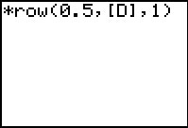
Problem 2 – Inverse Method
Now let’s use a quick method for using matrices to solve systems. Recall that matrix A contains the coefficients of x and y and matrix B contains the constants.  To do this, multiply the inverse of matrix A by matrix B.  Enter the command [A]⁻¹[B] and press . The resulting matrix contains the solution.  - How does this solution compare to the solution in Problem 1? | 