Open the TI-Nspire document Residuals.tns.  In this activity, you will investigate a residual plot for a set of data after selecting a regression model. The residual plot is used to justify the choice of a function model based on an analysis of the residuals. |  | 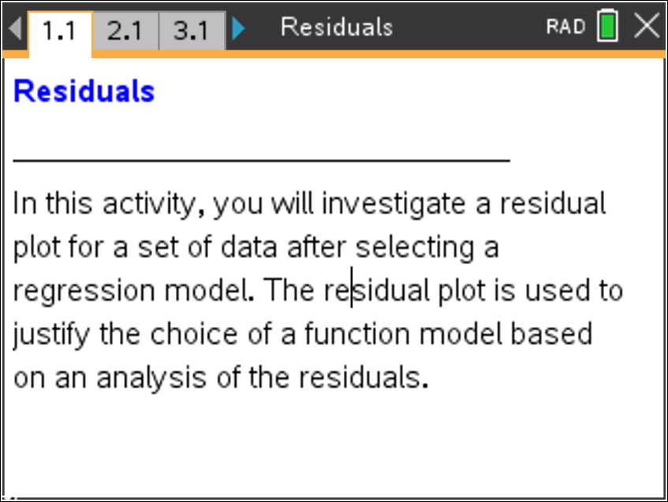
Move to page 2.1

Part 1
Use the following data set in Part 1.

 | –1 | 0 | 2 | 5 | 7 | 10
 | –7 | –4 | –1 | 6 | 8 | 16

 | - Enter the x values in the column labeled xvalue. Enter the y values in the column labeled yvalue.
 | Add a page by pressing /~> Add Calculator. Press b . > Statistics, > Stat Calculations, > Linear Regression (mx + b). For X List: select xvalue and for Y List: select yvalue. Press enter for OK..  What is your linear regression equation? |  | 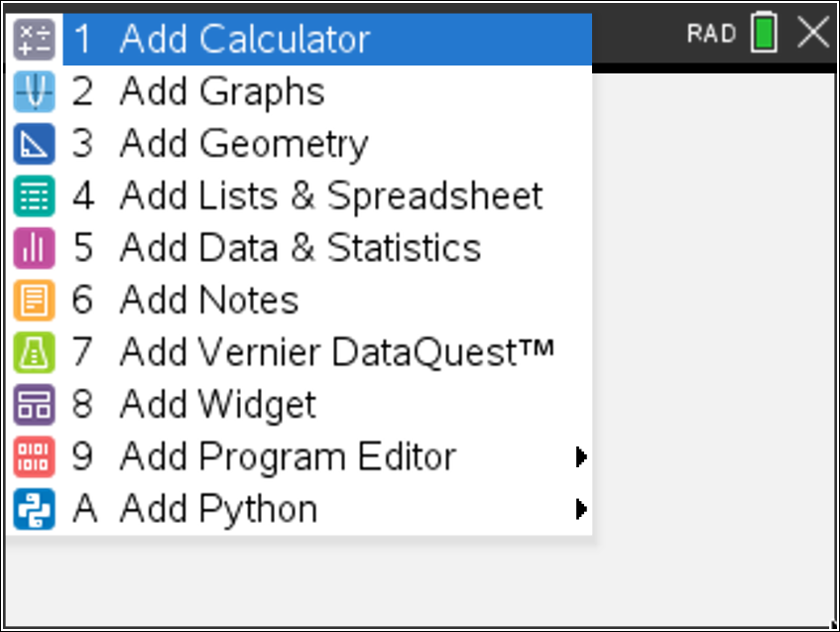
- Add a page by pressing /~. > Add Data & Statistics. Click in the lower gray region to select xvalue and click in the left gray region to select yvalue.

Note: To show the graph of the linear regression equation, press b . > Analyze, >Regression, and> Show Linear (mx + b). To hide the graph of the linear regression equation, , press b and >Analyze, >Regression, and >Hide Linear (mx + b).

The residual is the actual value minus the predicated value. A regression model is justified as appropriate for a data set if the residuals of a regression, the residual plot, appear without pattern. To view the residual plot, click in the left gray region and select stat.resid.

Does your residual plot have a pattern? Would a linear regression be appropriate for this data set?
3. Add a page by pressing /~. >Add Calculator. To evaluate the predicted values, type f1(–1) and then calculate the residual when x is –1. Calculate f1(0) and then calculate the residual when x is 0. Notice that one residual value is negative and one is positive. What does this tell us about the predicted value as being an underestimate or an overestimate?

Note: To view the residual list for all of the data points, press h and> stat.Resid. Scroll to the right to see more values.
Move to page 3.1.

Part 2

Use the following data set in Part 2.

 | –1 | 0 | 1 | 2 | 4 | 5
 | 0.2 | 0.6 | 0.9 | 2.1 | 7.9 | 16.2

 | 4. Follow the steps in Part 1. Enter the x values in the column labeled xvalue. Enter the y values in the column labeled yvalue. Compute a linear regression, view the scatter plot, and view the residual plot. Does your residual plot have a pattern? Would a linear regression be appropriate for this data set?
 | 5. Now compute an exponential regression. Add a page by pressing /~. Select> Add Calculator. Press b . Select > Statistics, >Stat Calculations, then> Exponential Regression. View the residual plot. Does your residual plot have a pattern? Would an exponential regression be appropriate for this data set?

