Problem 1 – Introduction
1. A permutation is a way of selecting objects from a set, in which order
– is important. – is not important. – cannot be determined.

2. A combination is a way of selecting objects from a set, in which order
– is important. – is not important. – cannot be determined.

3. List several examples of permutations.

4. At the right, there are 3 shapes. Draw the different arrangements for these, assuming that the shapes need to be in a row and none of them can be repeated. Make sure that none of your pictures are the same. How many arrangements were you able to make?

5. You have a set of four letters (A, B, C, and D). There are 4! ways to order the letters. Try to find all of the different ways below. Press     to evaluate 4!.

Problem 2 – Horse Races
The permutation and combination formulas are explored. _{n}P_{r} = and _{n}C_{r} = where n = number of objects in the set, and r = number of items chosen.
6. In a race with 10 horses, how many different ways can the horses finish? Order is important and every horse must finish the race. Press   to find the _{n}P_{r} and _{n}C_{r} commands.

7. How many different horses could finish first?

8. How many ways are there to rank the winning horses? In other words, how many ways can you arrange the top 3 horses?
Problem 3 – Combination Lock or Permutation Lock?
Combination lock? Or permutation lock? Look at the lock to the right. A ‘combination’ of the lock consists of 3 numbers with no repeated numbers.  9. How many possible “combinations”are there for the lock?  10. How many possible “combinations” are there for the lock in the previous problem if repeated numbers are allowed? How is this different from a combination or a permutation? |  |  | 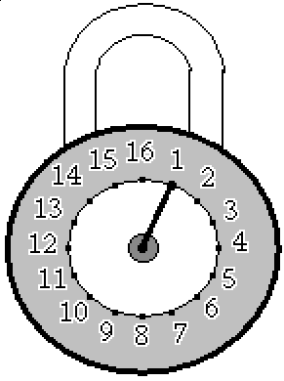
Additional Practice
11. Out of your favorite 5 games, how many ways are there to choose 2 games to play?

12. In a class of 22 students, how many ways are there for 4 students to be chosen for a committee?

13. In a class of 22 students, how many ways are there for 3 students to be elected to 3 officer positions?

14. An ice cream shop offers 8 different toppings. How many ways are there to pick 2 different toppings?

15. In a city, there are 9 local radio stations. How many ways are there to rank the Top 2 in Town?

Extension – Tree Diagrams
A salon is offering a special where customers can get a haircut, manicure, and pedicure for a discount if they are scheduled together. These services can be scheduled in any order. How many different ways can these services be scheduled?
A tree diagram is a way for you to ‘see’ the possible ways to choose objects. Create a tree diagram for this situation.

