Problem 1 – Solving Graphically
1. Solve the following system of equations using an algebraic method, substitution, or elimination.
Show your work and record your solution below:

Solution: x = _____; y = _______
Now use the calculator to solve the system of equations graphically. Press o and enter the equations next to Y1 and Y2.  Then press q and select ZStandard to get a graphing window with values from –10 to 10 as well as to observe the graphs of the two equations. | 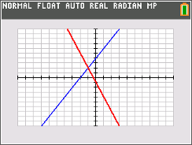
To find the point of intersection, press y / and choose intersect. Now, move the cursor to the observed point of intersection and press Í three times.
2. How is the point of intersection related to the algebraic solution of a system of equations?

Problem 2 – Creating a System of Equations
Press … Í and enter 5 in list L1 and –1 in list L2. Make sure the list is empty before entering the values. | 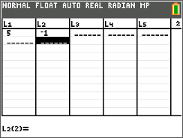
Press y , and set up Plot1 to graph a scatter plot of L1 and L2. This will plot the point (5, –1). | 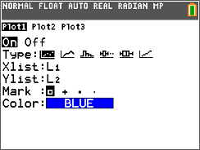
Enter the equations Y= 1X+3 and Y=1X–1 into the Y= screen next to Y1 and Y2.  Press s and observe that the two lines do not intersect. Change the values of the integers in these equations so that they intersect at the point (5, –1).  3. Record the equations of the lines: | 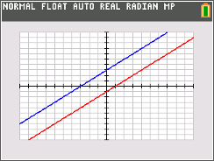
Have your partner solve your system of equations algebraically to confirm the solution is the intersection point, or use the intersect command.
Problem 3 – Infinite or No Solutions
Enter the equations Y= 2X+3 and y = 0.5X–1 in the Y= screen and observe that the two lines intersect.  Change the values of the coefficients and constants in these equations so that they do not intersect.  4. Record your equations: | 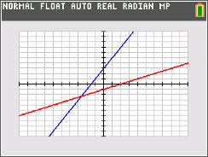
5. What do the equations or lines have to have in common so that they do not have a solution?

Now, change the values of the integers so they represent a system of equations with infinite solutions.
6. Record your equations:

7. What do the equations or lines need to have in common to have infinite solutions?

