Open the TI-Nspire document It_Takes_Guts.tns.  Hey, Batter Batter! You can't hit! You can't hit! Have you ever heard that jeer at the ballpark? Was it ever aimed at you? Imagine yourself coming up to bat. The bases are loaded, there are two outs, and the winning run is on third base. How would you respond in this situation? Would you keep your cool? | 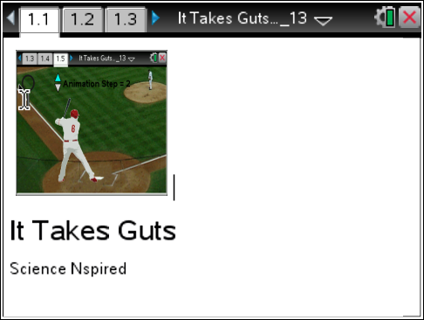
Move to pages 1.2 – 1.4 and read the background information for this activity.
Your body is made up of many systems that work together to help you grow and stay healthy. The digestive system breaks down the food you eat and absorbs the nutrients into your blood. The circulatory system delivers those nutrients to all of your organs to keep them alive and working. The urinary system removes wastes from your blood that your body doesn't need.
But there's one system that has power over all of the others and helps your body respond when a situation occurs that makes you "nervous". You guessed it -- the nervous system!
So, let's go to the ball park and observe the nervous system's game plan in action!
Move to page 1.5.
Read the directions for the simulation.
- Select the handle of the magnifying glass and drag it over the body of the player. When you see a question mark appear, select the hot spot to see the body response. |  | 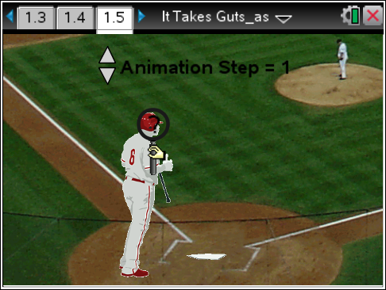
- Advance the simulation by selecting the up and down arrows (¤ and £).  - Repeat the steps until you have explored fourteen specific responses. (Hint- There are two per Animation Step.) |  | 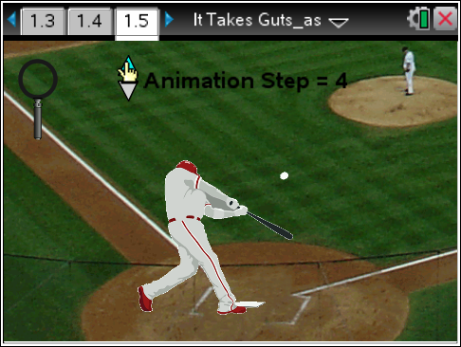
Tech Tip: To access the Directions again, select > Directions.
Tech Tip: To access the Directions again, select b or Document Tools () > It Takes Guts> Directions.
Move to page 1.6.

Q1. Record your data in the table below and/or in the .tns file on page 1.6.

ORGAN | RESPONSE
1
2
3
4

5
6
7
8
9
10
11
12
13

14

Move to pages 1.7 – 1.11. Answer questions 2 - 6 below and/or in the .tns file.

Q2. Which organ(s) decreased in activity? Choose all that apply.

A. muscles
B. stomach
C. kidneys
D. heart
E. salivary glands

Q3. Which system(s) decreased in activity? Choose all that apply.

A. digestive
B. nervous
C. muscular
D. circulatory
E. urinary

Q4. Which two organs had opposite responses to maintain water balance?

- stomach
- kidneys
- heart
- muscles
- sweat glands

Q5. This activity focused on the "fight or flight" response in which you either face the challenge or run from it. Briefly describe a situation when you experienced this response.

Q6. Your nervous system has an opposite response called “rest and digest” to calm the body down. Which of the following organs would increase in activity in this situation?

- heart
- stomach
- lungs

