Things to Remember…
This model is similar to a hot air balloon and provides a way to visualize adding and subtracting integers.
- Positive integers are represented by helium bags. They raise the balloon.
Negative integers are represented by sand bags. They lower the balloon.
- Addition is the operation of putting bags on the balloon.
Subtraction is the operation of taking bags off of the balloon.
- Always reset the balloon’s vertical position to 0 before beginning another calculation.
To begin, press p and find the HOTAIR program in the list. Press e to load the program.
Problem 1 – Integer addition
We will now use the model to find the sum 2 + (–6).  Press e to choose option 1, Integer Addition. |  |  | 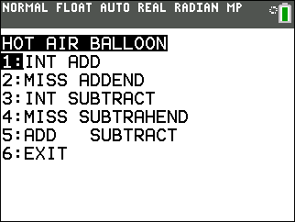
The program displays instructions. The right arrow adds a helium bag to the balloon, and the left arrow adds a sand bag. |  |  | 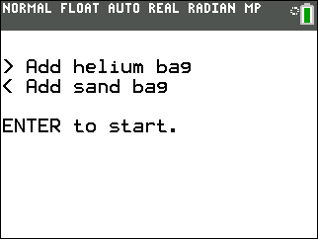
You can see the balloon at the bottom of the screen. The horizontal line represents ground level. The balloon’s vertical position is displayed at the bottom of the screen. Right now, the position is –12. |  |  | 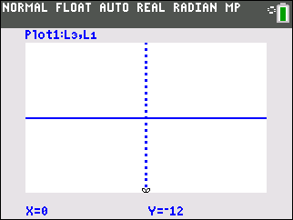
To view this addition a + b using the model, first reset the balloon to ground level by pressing the right arrow. |  |  | 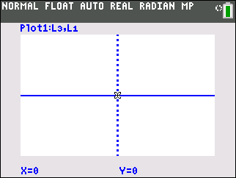
To find the sum 2 + (–6), understand what the sum represents in terms of the balloon. The 2 signifies adding two helium bags to the balloon, which raises it 2 units. Press the right arrow twice to add 2 helium balloons. |  |  | 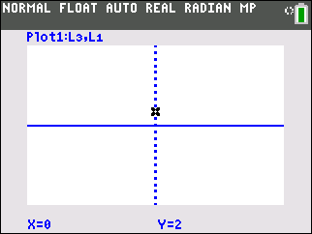
Adding –6 means you then add six sand bags, which lowers the balloon 6 units. Press the left arrow 6 times to add 6 sand bags. The balloon’s resulting position is the sum. With your partner, translate the following expressions into “balloon language” and use the model to find the sum. Remember to reset the balloon to ground level each time. When you are finished, press e to return to the menu. |  |  | 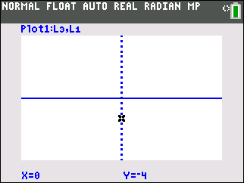
1. –4 + 7 = ___ | 2. 7 + 3 = ___ | 3. 5 + (–7) = ___ |  | 4. –5 + (–3) = ___
5. Calculate the values of 5 + (–5), 2 + (–2), and 4 + (–4). What value do you obtain when you add a number and its opposite?

6. A balloon has 7 helium bags attached to it. How many sand bags would you need to add to make the balloon sink to the ground?

Problem 2 – Missing addend
In this problem, you are given the value of a and the value of the sum a + b, but the value of b is unknown. Arrow down to option 2, Missing Addend, and press e.  Suppose you want to find the value of b such that  –4 + b = 3. First think about what this means in terms of the balloon. You know that you added 4 sand bags, and that the balloon ends up at 3. How many and which type of bag do you need to add to have a resulting position of 3? Input the value for A and press e. Then, input the sum and press e. |  |  |  |  |  | 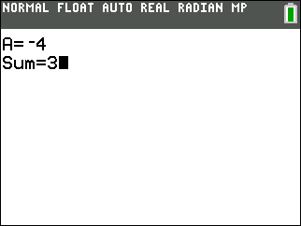
The program displays instructions. The right arrow adds a helium bag to the balloon, and the left arrow adds a sand bag, as with Integer Addition.  You can see the balloon at the bottom of the screen. Now there is also a target balloon to the right. The target balloon is positioned at the value of the sum. The task is now to find the value of b that is needed to move the balloon on the right to the same position as the target balloon on the left. |  |  |  |  |  | 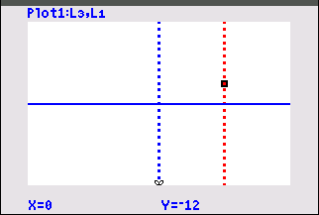
To find b using the model, first use the right arrow to reset the balloon’s vertical position to 0.  Add 4 sand bags by pressing the left arrow 4 times. |  |  |  |  |  | 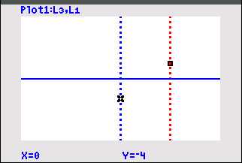
The target balloon is above your balloon’s position, so you need to add helium bags. Press the right arrow to add helium bags until the balloons line up. Count as you press to find how many helium bags you added. For this example, b = 7.  With your partner, translate the following equations into “balloon language” and use the model to find the missing addend. When you are finished, press e. to return to the menu. |  |  |  |  |  | 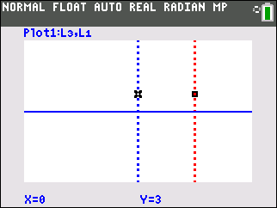
7. 2 + b = –3  b = ___ | 8. –6 + b = –1  b = ___ |  |  |  | 9. 5 + b = 1  b = ___ |  | 10. –2 + b = 4  b = ___
Problem 3 – Integer subtraction
The model also provides a way of visualizing the subtraction of integers. As with addition, positive integers are represented by helium bags and negative integers by sand bags. However, subtraction is the operation of taking off a bag. For example, the expression –2 – 5 translates to “put on 2 sand bags and then take off 5 helium bags.”
Arrow down to option 3, Integer Subtraction, and press e.
Use the model in the same manner as in Problem 1, with one difference: In this model, the right arrow removes a helium bag, and the left arrow removes a sand bag.  The model is the same as before. The balloon is at the top of the screen. |  |  |  |  |  | 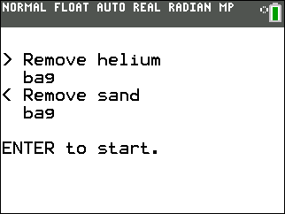
Reset the balloon at ground level by pressing the right arrow.  Move the balloon to its starting point, –2. |  |  |  |  |  | 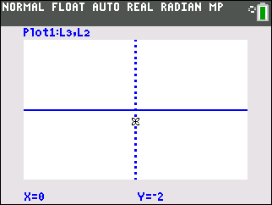
To remove 5 helium bags, press the right arrow 5 times.  The balloon falls 5 units to end at –7, which is the difference  –2 – 5. |  |  |  |  |  | 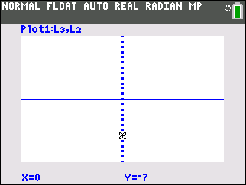
With your partner, translate the following expressions into “balloon language” and use the model to find the difference. When you are finished, press e. to return to the menu.
11. 2 – 7 = ___ |  | 12. –3 – 1 = ___ |  | 13. 5 – (–2) = ___ |  |  |  | 14. –4 – (–7) = ___
Problem 4 – Missing subtrahend
This model shows two balloons side by side—like the model from Problem 2, except that it is used to find a missing subtrahend rather than a missing addend.
Arrow down to option 4, Missing Subtrahend, and press e.
For example, find the value of b such that –3 – b = 8. In terms of the balloon, this means that the balloon ends up at 8, and you have used 3 sand bags. You need to find how many and which type of bag you must remove to have a resulting position of 8.
Input the value for A and press e. Then input the difference and press e.  Use the model in the same manner as in Problem 2, with one difference: In this model, the right arrow removes a helium bag, and the left arrow removes a sand bag. |  |  |  |  |  | 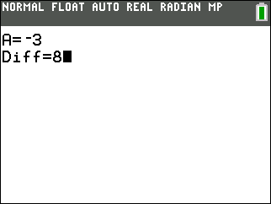
Your balloon is at the top of the screen, and the target balloon to the right represents the difference.  Reset the balloon at ground level by pressing the right arrow. |  |  |  |  |  | 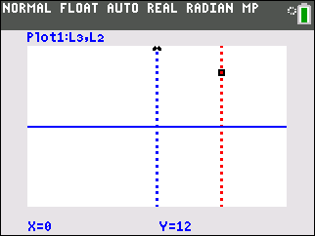
Move the balloon to its starting position, –3. |  |  |  |  |  | 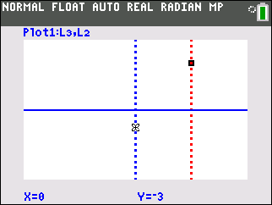
The target balloon is above your balloon’s position, so you need to remove sand bags. Press the left arrow to remove sand bags until the balloons line up. Count as you press to find how many sand bags you removed. For this example, you should find that b = –11. |  |  |  |  |  | 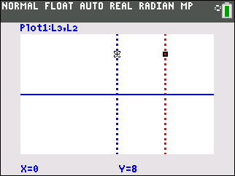
With your partner, translate the following equations into “balloon language” and use the model to find the missing subtrahend. When you are finished, press e. to return to the menu.
15. 6 – b = 9  b = ___ |  | 16. 5 – b = –3  b = ___ |  | 17. –4 – b = –1  b = ___ |  |  |  | 18. –2 – b = 6  b = ___
Problem 5 – Addition and subtraction exploration
Arrow down to option 5, Addition and Subtraction, and press e.  The balloon on the left is for addition and the one on the right is for subtraction. Use the up and down arrows to move between the two models.  For each of the following expressions, use what you learned from Problems 1 and 3 to translate into “balloon language” and then find each sum or difference. |  |  |  |  |  | 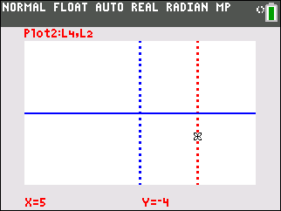
19. –2 – 4 = ___ |  |  | 20. –2 + (–4) = ___
21. 5 – (–6) = ___ |  |  | 22. 5 + 6 = ___
For each of the following equations, use what you’ve learned from Problems 2 and 4 to translate into “balloon language” and then find each missing addend or subtrahend.
23. –1 – b = 5  b = ___ |  | 24. –1 + b = 5  b = ___ |  | 25. 3 – b = –4  b = ___ |  |  |  | 26. 3 + b = –4  b = ___
Complete the following statements.
27. Taking off 8 sand bags is the same as putting on 8 ___________ bags.
28. Taking off 5 helium bags is the same as putting on 5 ___________ bags.
29. If a and b are any two integers, then a – b = a + ___. That is, subtracting a number is equivalent to adding its ___________.

To exit the program, arrow down to option 6 and press e.

