Open the TI-Nspire document Side_Side_Angle.tns.  How many triangles can you build given two sides and an angle? In this activity, you will answer this question by experimenting with segment lengths and angle measures. | 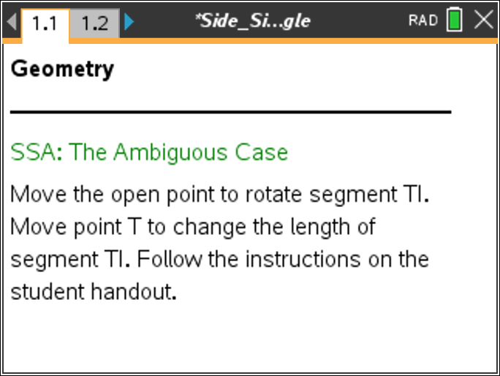

Move to page 1.2. | Press / ¢ and / ¡ to navigate through the lesson.
- Grab the open circle and rotate .  - What changes? What remains the same?  - Grab the open circle to rotate until a message appears that a triangle has been formed. How many triangles are formed when point T is on ? | 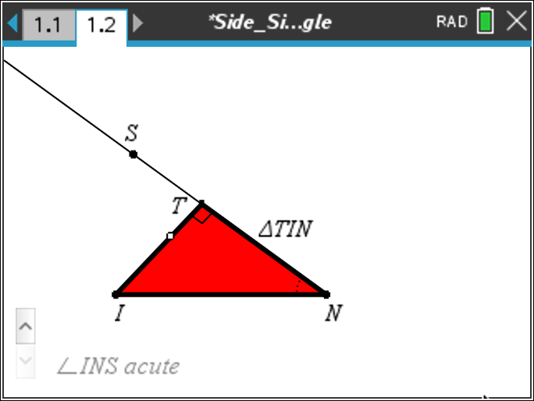
- Move the open circle so that point T is not on . Grab point T and drag it to make longer and shorter. Use the open circle to rotate .
- What changes? What remains the same?

- How many triangles can you form?

- Fill in the following tables given the relationship of to .
When INS Is Acute
Length Relationship of  to | Number of Triangles
TI = IN
TI > IN
TI < IN

Click Δ on the screen twice to change the size of INS to obtuse.
When INS Is Obtuse
Length Relationship of to | Number of Triangles
TI = IN
TI > IN
TI < IN

Click ∇ on the screen to change the size of INS to right.
When INS Is Right
Length Relationship of to | Number of Possible Triangles
TI = IN
TI > IN
TI < IN
4. a. Compare the three tables. What relationship between and will give you exactly one triangle?

b. State a general rule for being able to form exactly one triangle given any two sides and a non-included angle.

5. a. Given two segments and the angle formed between them (SAS), how many triangles can you build? Explain your thinking.

b. Given two segments and an angle not included between them (SSA), how many triangles can you build? Explain your thinking.

6. Sherri and Linda were given the information below. Will the triangles they each created using this information always be congruent? Why or why not?
- The measure of was 6 inches. The measure of was 7.5 inches. The measure of B was 45○.

- The measure of was 6 inches. The measure of was 7.5 inches. The measure of C was 45○.

- The measure of was 7.7 inches. The measure of was 6 inches. The measure of C was 45○.

- The measure of was 6 inches. The measure of B was 45○. The measure of A was 52○.

7. Why can SAS be used to prove triangles congruent but SSA cannot?

