Activity Overview
In this activity, you will create a new document to solve a linear system of three equations in three unknowns. You will learn three different strategies to solve the same linear system, one utilizing the Algebra menu of the Calculator application and each of the other two utilizing a Matrix. Any of the three methods can be used to solve a system of equations.

Steps

Step 1: Select c > New Document. Add a Calculator application.

Step 2: Method 1: linSolve( command from Algebra menu

- Press Menu > Algebra > Solve Systems of Equations > Solve Systems of Linear Equations. | 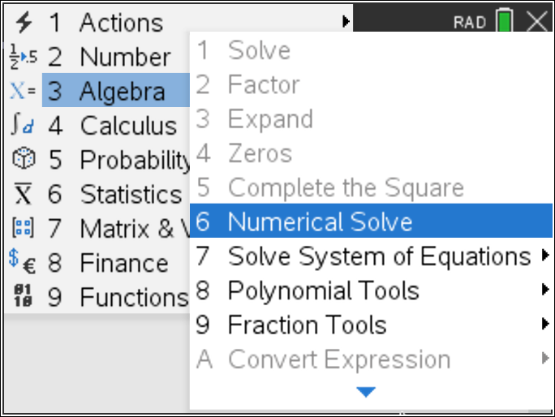
- Choose to solve a system of three linear equations. Press e to enter the variables that you will be using. Use p, c, and f to represent protein, carbohydrates, and fat. Press ·. | 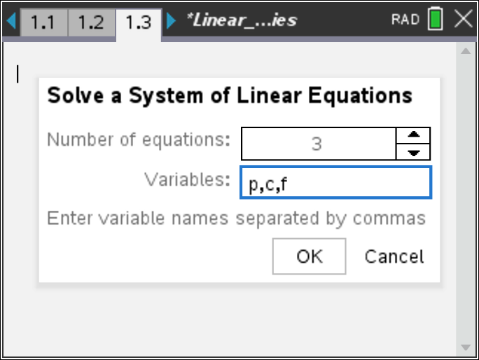
It would be a good idea to save your document. Press / » and name your document. Press e ¾. As you progress through this activity, remember that / d will undo your previous entry.

- Enter the information from question 1 of the activity. The screen capture on the right shows the three entries. Press e to move to the next equation. | 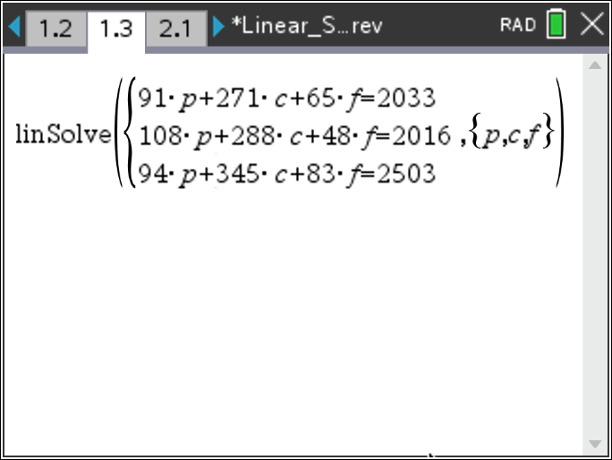
- Press · to solve the system. Note, p = 4, c = 4, and f = 9. | 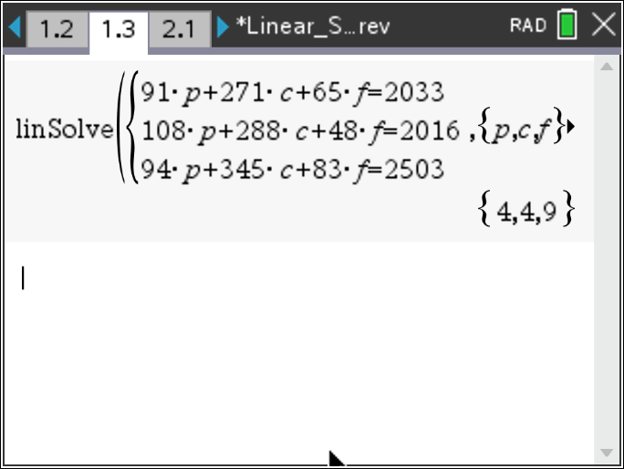
Step 2: Method 2: Reduced row-echelon method

- The same solution can be found by using the reduced row-echelon form of the matrix. Press ~ > Insert > Problem then Add Calculator Page.. | 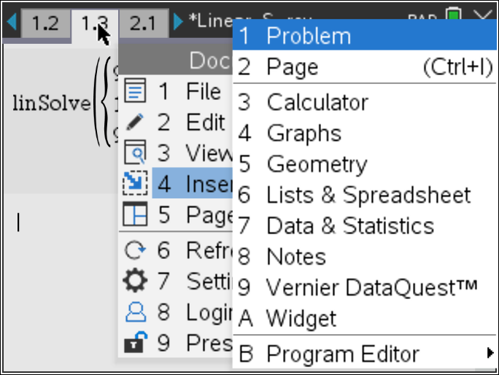
- Press Menu > Matrix & Vector > Create > Matrix. | 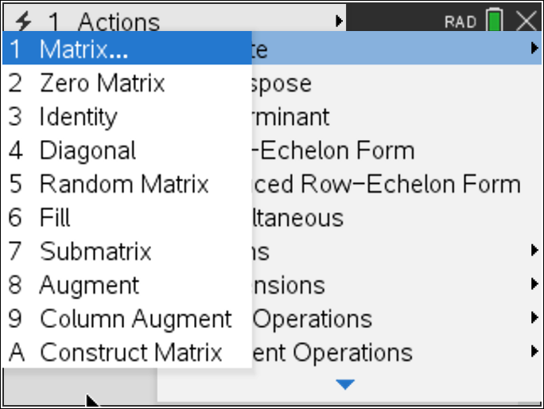
- The augmented matrix for a system of equations with three equations with three unknowns will have 3 rows and 4 columns. Press e to move around the page to make your selections. Highlight OK, and press ·. | 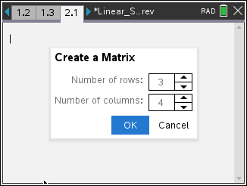
- After you input the information into the matrix, your screen should look like the one shown on the right. After you input all of the information, press ·.  The matrix shown is for the system of equations: | 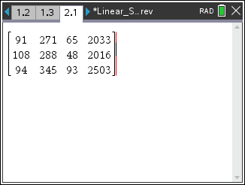
- Press Menu > Matrix & Vector > Reduced Row-Echelon Form.

- The screen will display rref(. Press / v to insert the answer from the previous line. | 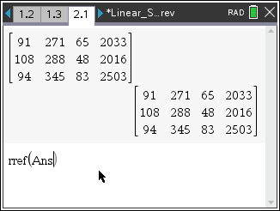
- Press · to see the resulting solution matrix.  Again, p = 4, c = 4, and f = 9. | 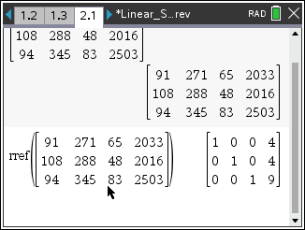

Step 2: Method 3: Matrix inverse

- The solution can also be found by using an inverse matrix. To add a Calculator page for a new problem, press ~ > Insert > Problem > Add Calculator.  Press Menu > Matrix & Vector > Create > Matrix. | 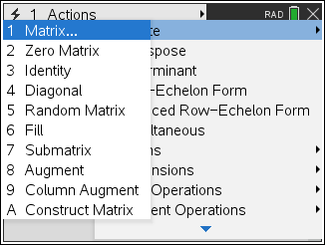
- Create a coefficient matrix(3X3) and a constant matrix(3X1) as shown.  Once again, the matrix shown is for the system of equations: | 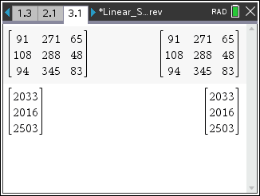
- Copy the coefficient matrix and raise it to –1 power to indicate the inverse matrix. Multiply this by a copy of the constant matrix. When you press ·, you will see the solution to the system.  In matrix notation, this is [A]⁻¹ · [B].  Again, p = 4, c = 4, and f = 9. | 