Problem 1 – Focus and directrix
To start, run the program PROPPARA.  Choose DefofParabola. The calculator displays:  (a) a parabola  (b) a point on the y-axis, and  (c) a horizontal line. | 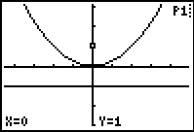
The graphing calculator is in Trace mode. Press the down arrow  to move the cursor onto the parabola. Use the left and right arrows   to move along the curve.  Choose a point on the curve and press .  A line segment, a, is drawn from this point to the point on the y-axis, and a second line segment, b, from your point to the horizontal line. The lengths of a and b are displayed. | 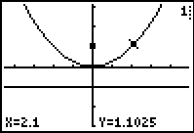
The calculator is again in Trace mode. Press  until the cursor is on the parabola. Use the  and  to choose another point, and press  again. The calculator draws new line segments and displays their lengths.
Repeat this process with several different x-values.
1. As you move along the parabola, what is true about the lengths of a and b?

The point (0, 1) is called the focus and the line y = –1 is called the directrix. The focus and directrix of a parabola are always the same distance from the vertex of the parabola. Listen as your teacher talks about the focus and directrix. Then answer the questions below.
2. What is the definition of the focus?

3. What is the definition of the directrix?

4. What is the distance from the vertex to the focus for this parabola?

Problem 2 – Creating a parabola
In this problem, you will use a given focus and directrix to create a parabola. Start the Cabri Jr. app and open the Cabri Jr. document called PARA1. Press □ to open the F1:File menu and choose Open…. Then choose PARA1 from the list. | 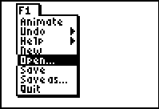
The figure shows two points, D and F, and a line L.  Move your cursor to point D. Press  to “grab” point D. Use  and  to drag it along the horizontal line.  5. What shape is being created by line L? | 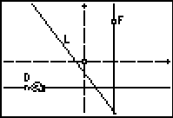
Place a point on line L using the Point on tool. Press  to let go of point D.  Draw a line segment from F to your point and then another segment from your point to D using the Segment tool.  Now, measure each segment using the D. & Length tool.  6. What is true about the measurements? | 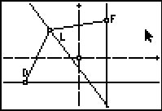
Next, find the distance from the vertex to the focus of the parabola you are creating. Grab point D, and move it so that it is on the line that goes through point F.
Then grab the point that you placed on line L and move it so that it is also on the line that goes through point F.
7. What is the distance from the vertex to the focus of the parabola you are creating?

To get the x-value of the vertex, use the Coord. & Eq. tool to display the equation of the vertical line. To get the y-value, display the equation of the horizontal line L.
8. What is the vertex of the parabola you are creating?
Use the Coord. & Eq. tool to find the coordinates of point F. Record them here.
9. F:

After you record the coordinates, you may choose to Hide or Delete them to make the figure easier to read.
Use the Locus tool to create a parabola. Select the tool, select line L, and then select point D.
10. What do you see on your calculator screen?

Move the focus around the calculator screen.
11. As the focus gets closer to the vertex, what happens to the parabola?

12. What about as you move the focus further away from the vertex?

Move the focus back to its original position. Now, write an equation for your parabola. You already know the location of the vertex. You need to find the scale factor or the a-value for your parabola.
Multiply the distance from the vertex to the focus by 4 and then take the reciprocal. Use this as your a-value.
13. Write an equation for your parabola in vertex form.

To check your answer, press   to exit the CabriJr app. Then press □. Clear out any equations and turn off any stat plots. Enter in Y1 the equation from Question 13 and graph it.
14. Did it match your Cabri Jr. graph? (The window settings are the same.)

Extension: Focal Width
Run the PROPPARA program again. Choose FocalWidth from the menu. A parabola is graphed, along with its focus and directrix. There is also a segment through the focus parallel to the x-axis. The length of this segment is given. Examine the figure.
Press . The program prompts you to enter another value for a and displays a new graph. Experiment with different values of a. Then answer the questions below.

- What is the relationship between the length of the focal width and the a-value in the equation of the parabola?

- How is the distance from the vertex to the focus related to the distance you found?

