Open the TI-Nspire document ApplicationsofSimilarFigures.  In this activity, you will use similar figures to solve real-world applications. You will use similar rectangles to enlarge a photo and similar triangles to estimate the height of a building. | 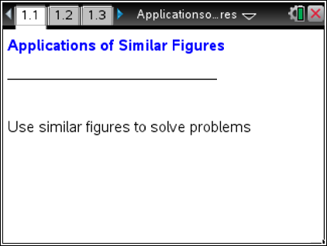

Problem 1 – Similar Rectangles
1. Suppose you have a 4 in by 5 in photo that you want to enlarge for an album. You would like the enlarged picture to take up almost an entire page of a 7 in by 10 in album, leaving some space at the top for a picture title. What will have to be true about the picture and the enlargement so you do not distort the picture?

2. On page 1.2, there are two rectangles. One rectangle represents the picture and the other rectangle represents the enlargement. What do the ratios represent? Answer questions 2-4 before moving the open point.

3. Are these rectangles similar? Explain.

4. How does the ratio of the heights of the pictures compare with the ratio of the widths? What should these ratios be for similar rectangles?
5. Drag the open circle of the larger rectangle until the ratios are equal. What does the height of the larger rectangle need to be in order for the rectangles to be similar? How much space will be left at the top of the 7 x 10 inch page for the picture title?

Problem 2 – Similar Triangles
The Greek mathematician Thales found a way to use similar triangles to estimate the height of a pyramid in Egypt by placing a rod at the tip of the pyramid's shadow.
You decide to use the same method to find the height of a building. You will be painting the building and need to estimate the amount of paint needed for the project.
The diagram on page 2.1 shows a 6 unit tall pole that was placed near the tip of the shadow of the building. Select the up arrows for step-by-step directions.
6. On page 2.1, use the Segment tool (MENU > Geometry > Points & Lines > Segment) to create two triangles by connecting the top of the pole to the end of its shadow and then the top of the building to the end of its shadow. How do the corresponding angles in the two triangles compare?

7. Use the Angle tool (MENU > Geometry > Measurement > Angle) to find the angle measures of the other four angles in the triangles. (When finding the measure of an angle, the second point is the vertex of the angle you want to measure.) How do these measures compare to your response to Question 6? Can the angle measures be used to determine if the triangles are similar?

8. What is the ratio of the length of the pole and its shadow? What will be the ratio of the height of the building and its shadow?
9. Using what you know about similar figures, find the height of the building. Explain your reasoning. Check your solution by using the Length tool (MENU > Geometry > Measurement > Length) to find the height of the building. (Assume the units of the length measurements are in feet.)

