When the conditions for a binomial experiment are met, the test statistic for testing a claim about a proportion is , where is the sample proportion, p is the claimed population proportion, and n is the number of trials.

Problem 1 – Lefties
One claim states that 10% of Americans are left-handed. A student wants to test if this claim is true for the students at his school. He surveyed 82 randomly selected students and found that 5 of them are left handed.
Is this enough evidence to say that the 10% figure does not hold for his school? Test the claim at α = 0.05.
1. Write the null and alternative hypotheses.

2. Calculate .

3. Calculate the test statistic, z.

4. Calculate the critical values by using the invNorm command in the DISTR menu ( ).  5. Do you reject or fail to reject the null hypothesis? Why? | 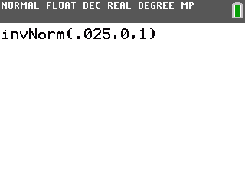
Press  and set the values equal to the following.
Xmin = –5, Xmax = 5, Xscl = 1, Ymin = –0.1, Ymax = 0.5, Yscl = 0.1
The P-value can be found by using the ShadeNorm command. It is located in the DRAW menu which is accessed by pressing  .  The format is lower bound, upper bound, mean, standard deviation. Use –1E99 for negative infinity and 1E99 for positive infinity. (Type E by pressing  .) | 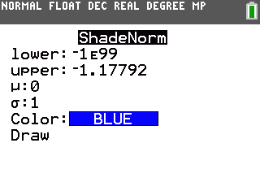
6. What is the area to the left of the test statistic?
7. What is the P-value?

8. How does the P-value confirm your decision to either reject or fail to reject the null hypothesis?

Problem 2 – Loaded Cube
A number cube is suspected of being “loaded,” that is, it seems more sixes come up than any other number. If a six comes up on 28 out of 95 rolls, test the claim that the proportion of sixes is greater than what it should be. Test the claim at α = 0.01.
9. What is p?

10. What is ?

11. Write the null and alternative hypotheses.

12. Calculate the test statistic, z.

13. Calculate the critical value. (Remember that this is a right-tailed test.)

14. Do you reject or fail to reject the null hypothesis? Why?

15. Find the P-value. Explain how it confirms your decision to either reject or fail to reject the null hypothesis.

Problem 3 – Cats and Dogs
One source states that 36% of American households have cats and 39% have dogs. A student wants to test if this is true in her neighborhood. Out of 42 randomly selected households, 17 have cats and 12 have dogs.
Is this enough evidence to say that either of the 36% and 39% figures does not hold for her neighborhood? Test the claims at α = 0.10.
16. Write the null and alternative hypotheses for the cat claim.

Write the null and alternative hypotheses for the dog claim.

17. Calculate for the cats.
Calculate for the dogs.
18. Calculate z for the cats.
Calculate z for the dogs.
19. Calculate the critical values.
20. Cats: Do you reject or fail to reject the null hypothesis? Why?

Dogs: Do you reject or fail to reject the null hypothesis? Why?

Press , choose TESTS and select 1-PropZTest…  Find the P-values for the cats and dogs by typing p, x, n, and choosing the correct type of test.  21. Cats: What is the P-value?  Dogs: What is the P-value? | 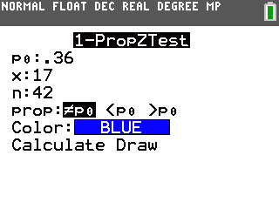
22. Explain how these values confirm the decisions you made to either reject or fail to reject the null hypotheses.

