Part 1 – Wide and Long
Find the dimensions and area of each figure.
1. Length: ___________ Width: ___________  Area: ___________ |  | 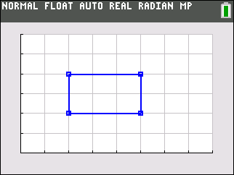
2. Length: ___________ Width: ___________  Area: ___________ |  | 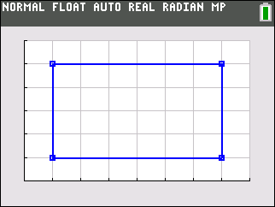
3. Length: ___________ Width: ___________  Area: ___________ |  | 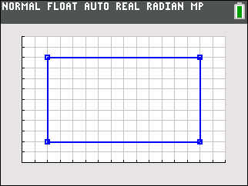
4. How do the dimensions of Rectangle 1 compare to Rectangle 2? The area?

5. How do the dimensions of Rectangle 2 compare to Rectangle 3? The area?

6. How do the dimensions of Rectangle 3 compare to Rectangle 1? The area?

7. What happens to the area of a figure when the length and width double? Why is this true?

Part 2 – Making Predictions
Given the relationship you found in Problem 1, find the area of the unknown figure. Draw a figure to help show your answer.
8. A rug has an area of 15 square feet. What is the area of the rug measured in square inches? |  | 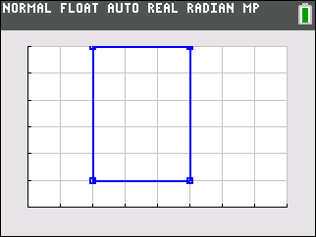
9. Joseph is building a new storage building. He thinks the current size, 9’ × 6’ does not have enough area inside. What will the area be if he doubles the length of the sides?

10. Shelia created a blanket that is 3 feet by 4 feet. Her mom asked what the area is in square inches instead of feet.

Part 3 – Finding the Missing Sides
Two rectangles are drawn sharing a common side. The figures should share the largest side possible. Find the missing sides in each problem.
11. Figure 1: 90 sq inches _____ × _____  Figure 2: 72 sq inches _____ × _____ | Use the gcd( feature to find the largest possible side the two figures share. Press m ► 9, then enter 9 0 , 7 2 ) and press e to evaluate.
12. Figure 1: 25 sq feet _____ × _____  Figure 2: 15 sq feet _____ × _____ | 13. Figure 1: 140 sq yds _____ × _____  Figure 2: 84 sq yds _____ × _____
14. Figure 1: 100 sq cm _____ × _____  Figure 2: 80 sq cm _____ × _____ | 15. Figure 1: 225 sq feet _____ × _____  Figure 2: 75 sq feet _____ × _____

