In this activity you will create graphs from lists of data with the help of the program CORLATE and determine if the data sets have a positive or negative correlation coefficient. You will also determine the linear regression for each data set and calculate the correlation coefficients. You will then use the linear regression on your Home screen to predict the values of unknown data points.
Problem 1 – Home Price vs. Square Footage
Discuss this first question with a partner and record your thoughts before looking at the data.
- Describe how you think the selling price of a house relates to the amount of area of the house or square footage. State if there is any correlation. Find the variables. State which variable is the independent variable. State which variable is the dependent variable. Discuss what else the price of a house might depend upon.

Now run the program CORLATE and select option 1, HOUSES. The area measured in square feet of a house is in L1. The selling price of the corresponding house (given in hundreds of dollars) is in L2. Once the data is graphed, consider if you still agree with your initial predictions.
- Explain the meaning of the point (2650,2050). Include units.  - Choose the type of correlation (circle your answer).  - positive negative | 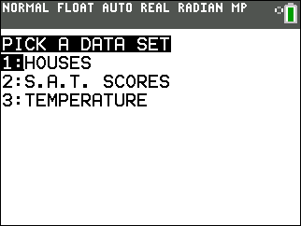
- very strong moderately strong moderately weak very weak
- Predict the value of the correlation coefficient to one or two decimals. Explain your reasoning.

On the Home screen, calculate correlation coefficient and the linear regression equation. Press S, move the cursor to the CALC menu, and select LinReg(ax+b). Then, enter the list of your independent variable, the list of your dependent variable, and store the regression equation in Y1 using a ª.  - Find the correlation coefficient, r. Describe how the coefficient compares with your description of the correlation. Explain how your prediction compares. | 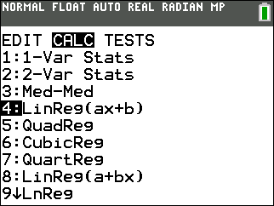
- Write down the regression equation.

Press % to return to the scatter plot. The regression equation will be graphed with the plot.
Press $, and then use the down arrow ; to view the equation in the top-left corner.
- State the sign of the slope. Explain how this relates to the sign of the correlation coefficient. Describe the meaning of the slope in the context of the data. Also, explain the y-intercept in the context of the data.

Use the regression equation or the table feature to determine the following predictions.
- Predict the price of a house that has 3,500 sq. ft.

- Predict the number of square feet for a house costing $150,000.

- Predict the price of a house with 50,000 sq. ft. State if this prediction seems reasonable based on the data given. Explain.

- Predict the number of square feet for a house costing $5.2 million. State if this prediction seems reasonable based on the given data. Explain.

Problem 2 – S.A.T. Verbal and Math Scores
Discuss the next question before looking at the data. You will be analyzing Math and Verbal scores from male and female students who took the SAT exam.
12. State if you think the students who score well on the Verbal section of the SAT exam also score well on the Math section. Discuss and record your thoughts on which variable is the independent and dependent variable. State if you think there will be a correlation.
Run the program CORLATE and select option 2, S.A.T. SCORES. The Verbal scores for a sample of 162 students are located in L1. The Math scores for those students are in L2.
13. Choose the type of correlation (circle your answer).
- positive negative
- State if you think the correlation is stronger, weaker, or about the same as the data set from Problem 1.
Find the linear regression equation the same way you did in Problem 1.
14. State the correlation coefficient.

15. Record the regression equation and explain the meaning of the slope.

Return to the scatter plot to view the regression equation. Use the regression equation to determine the following predictions.
16. Predict the Math score if the Verbal score is 500.

17. Predict the Verbal score if the Math score is 620.

18. State if there is a relationship between these two variables. State if one is dependent on the other.
State if an increase in one means an increase in the other. In other words, while there is correlation,
discuss if there is causation.

Problem 3 – Latitudes and Temperatures in January
In this problem, you will investigate the temperature of locations at various latitudes on Earth in the month of January.
19. State if you think the latitude of a location is related to the temperature at that location. Discuss and
record you thoughts. State the independent and dependent variables. Discuss the other variables that
affect the temperature of a location.
Run the program CORLATE and select option 3, TEMPERATURE. The latitude (in degrees north of the equator) of 50 different locations is displayed in L1. The average minimum January temperature in °F for the 50 locations is in L2.

20. Predict the type of correlation (circle your answer).
a. positive negative
b. very strong moderately strong moderately weak very weak
Find the linear regression equation and store the equation in Y₁.
21. State the correlation coefficient.

22. Record the equation and explain the meaning of the slope and y-intercept.

Use the regression equation to determine the following predictions:
23. Predict the average minimum January temperature for a city with latitude 28.3 degrees North.

24. Predict the latitude for a city with an average minimum January temperature of 46°.
Now discuss and investigate what would happen if the temperatures were changed from Fahrenheit to Celsius.
25. If you know that 0 ºC is 32 ºF and 100 ºC is 212 ºF, state the formula to convert the temperature in
degrees Fahrenheit to a temperature in degrees Celsius. Create a third list that converts the
temperatures to Celsius by entering the formula in the top of L3.

26. Use ` ! to add another å and find the new regression equation. Record the equation and
correlation coefficient.

27. Describe what happened to the plot of Celsius vs. Latitude compared to the Fahrenheit vs. Latitude.
Explain.

