Problem 1 – Sum of Arithmetic Sequences
Step 1: Press S e and enter the numbers 1 to 10 in list L1.  Step 2: Enter the numbers in reverse order into list L2.  Step 3: Now, arrow to the top of the L3. Enter L1+L2 by pressing ` 1 + ` 2 e. | 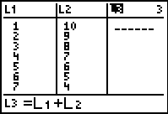

- What do you notice about the sums in list L3?

- How do you find the sum of L3 without adding all the values individually?

- How does the sum of L3 compare to the sum of L1?

Repeat the steps above for lists:  –3, 0, 3, 6, 9, 12, 15 and 10, 8, 6, 4, 2, 0, –2  Note: You will need to clear L1, L2 and L3 each time by arrowing up to the top of each list and pressing C. |  | 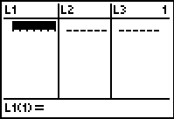
- Based upon what you have observed from the three previous investigations, conjecture a formula for the sum of an arithmetic sequence.

- Apply the formula to find the sum of the following sequences. Show your work.
- 9, 1, –7, –15, –23, –31, –39

- 3, 13, 23, 33, 43, 53, 63, 73, 83, 93, 103, 113

Problem 2 – Sum of Geometric Sequences
Step 1: Press S e and enter the numbers 1, 2, 4, 8, 16 in list L1. Examine L1 to determine the common ratio between the terms.  Step 2: Multiply each of the terms in L1 by the common ratio. Arrow to the top of L2 and enter  L2*(your common ratio). |  | 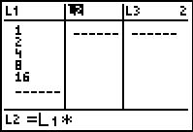
Notice the diagonals of the two columns have the same values. If you subtract the values that are the same, only two values remain.
Step 3: What is the difference between these two values?

Step 4: What number do you need to divide your difference value in order to get the sum of the values in L1?

- Rewrite each value in L1 using the common ratio. How can you find the difference value you calculated only using the values in L1?

Step 5: Repeat the steps above for lists:
1, 3, 9, 27, 81 and 1, 4, 16, 64, 256
Remember to clear your lists after each investigation.
- Based upon what you have observed from the three previous investigations, conjecture a formula for the sum of a geometric sequence.

- Apply the formula to find the sum of the following sequences. Show your work.
- 1, , , , , | - 1, , , , |  | - 1, –2, 4, –8, 16, –32, 64

